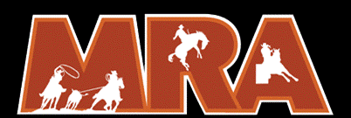

Parent/ Guardian consent: I certify that the age and date of birth of the above named child is correct, and I hereby consent to the participant of my/our child in the Minnesota Rodeo Association. I agree that in no event will I hold the MRA, its agents, or employees liable for injury or property damage during participation at a MRA sanctioned rodeo or while in route to or from a MRA sanctioned rodeo.
Parent/ Guardian of Applicant Signature:_________________________________________________Date _____________
(Parent/Guardian of Applicant complies with the releases of liability as designated by the MRA)

NOTARIZED SIGNATURE of parent or guardian required for applicants under the age of 18 years.
The foregoing instrument was acknowledged before me this ___________day of __________________________________, 2026. By _______________________________________________parent or guardian of the above MRA contestant and I certify that the above information is true to the best of my knowledge.
Stamp of Notary: Date: My commission Expires:

